Exp 01.Create a simple cloud software application and provide it as a service using any
Cloud Service Provider to demonstrate Software as a Service (SaaS).

Aim
To create a simple Movie Ticket Booking cloud application using Zoho Creator and provide it as a service over the cloud to demonstrate the Software as a Service (SaaS) model.

Procedure
1. Start and Login – Sign in to Zoho Creator with your Zoho account.
2. Create Application – Choose “Create New App” and select from template or build from scratch.
3. Design Forms & Reports – Add forms for input (e.g., user details, items) and reports for displaying data.
4. Add Logic/Workflows – Use Deluge scripts to automate actions like validation and notifications.
5. Set Roles & Permissions – Assign access levels to users for secure usage.
6. Deploy & Share – Publish the app, get the URL, and provide it to users as SaaS

Output
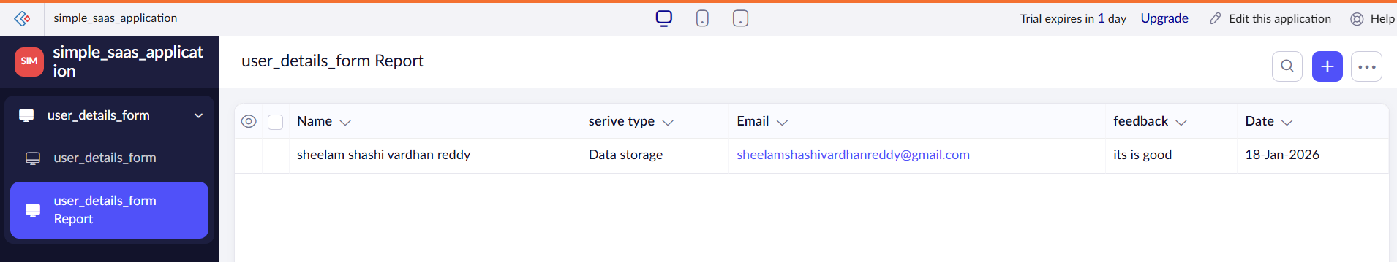

Result
Thus, a simple cloud-based application was successfully created and deployed using Zoho Creator, and it was provided as a Software as a Service (SaaS) model.

